**TABELS :**

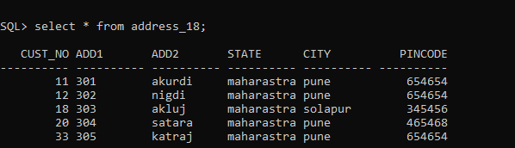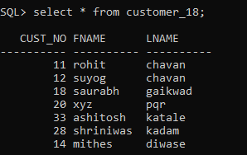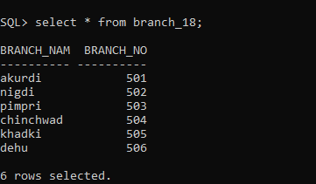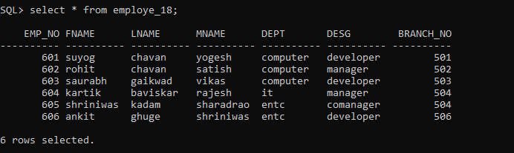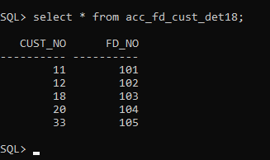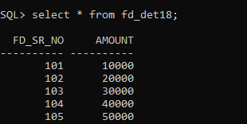

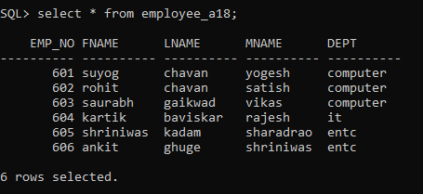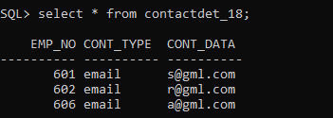

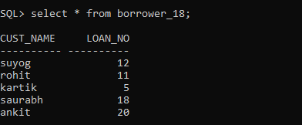

1. Create following Tables

cust_mstr(cust_no,fname,lname)

add_dets(code_no,add1,add2,state,city,pincode)

Retrieve the address of customer Fname as 'xyz' and Lname as 'pqr'

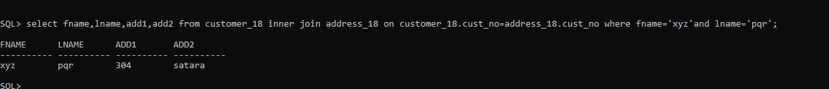

2.Create following Tables

cust_mstr(custno,fname,lname)

acc_fd_cust_dets(codeno,acc_fd_no)

fd_dets(fd_sr_no,amt)

List the customer holding fixed deposit of amount more than 5000

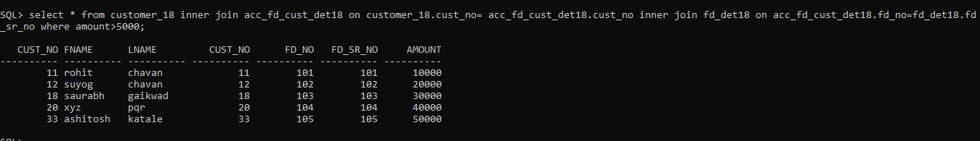

3. Create following Tables

emp_mstr(e_mpno,f_name,l_name,m_name,dept,desg,branch_no)

branch_mstr(name,b_no)

List the employee details along with branch names to which they belong

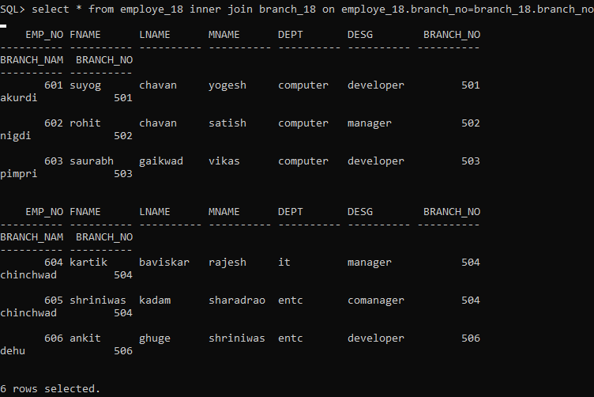

4. Create following Tables

emp_mstr(emp_no,f_name,l_name,m_name,dept)

cntc_dets(code_no,cntc_type,cntc_data)

List the employee details along with contact details using left outer join & right join

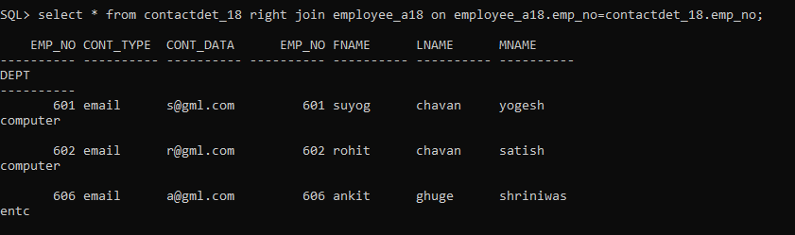

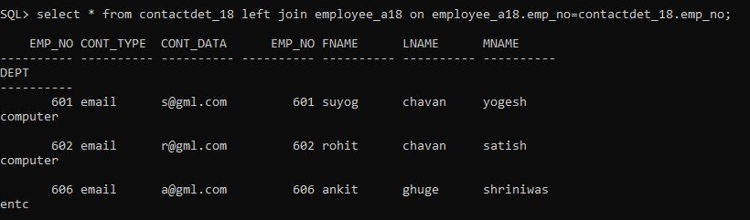

5. Create following Tables

cust_mstr(cust_no,fname,lname)

add_dets(code_no,pincode)

List the customer who do not have bank branches in their vicinity.



6. a) Create View on borrower table by selecting any two columns and perform insert update delete

operations

b) Create view on borrower and depositor table by selecting any one column from each table

perform insert update delete operations

c) create updateable view on borrower table by selecting any two columns and perform insert

update delete operations.

